Computer Science Jeroo Lab 2E – Great Escape Lab Value - 100

Lab Goal: This lab was designed to teach you more about using method calls to solve problems. You must get comfortable with single Jeroo methods being called multiple times in solving problems that involve the same actions being repeated. This lab requires precision in creating a single method that will allow each Jeroo to escape and locate the flower. Careful planning will allow you to see that methods can be re-usable – a big part of the power that methods offer the programmer.
Lab Description: Create a single method that allows your Jeroo to navigate through the complex maze and bringing the Jeroo to a stop ON the flower and pick it for lunch. As each Jeroo has only a single flower to use in breaking out, you must navigate them through the maze of dangerous nets before arriving safely at the flower.
Once your method works for the first Jeroo, immediately try it for the other Jeroos. Failure to rescue them may result in dead Jeroos as they try to escape and seek out food.
Files Needed ::
Jeroo_Lab2E.jsc
GreatEscape.jev

Starting Screen:

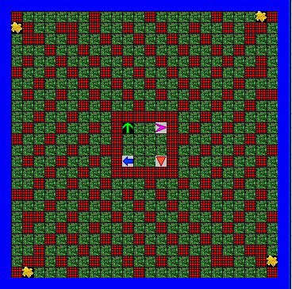
algorithm help

Preconditions –
- 1 Flower to start
Postcondition –
- Arrive ON the final Flower
- Pick the flower
- Jeroo is Facing the water – not in water

Hint – Test your method often – make sure each part of it works as you run your Jeroo through the dangerous maze.

Finished Screen:
